**Project Design Phase-II Technology Stack (Architecture & Stack)**

|  |  |
| --- | --- |
| Date | 8 November 2022 |
| Team ID | PNT2022TMID03166 |
| Project Name | Smart Farmer- IoT Enabled smart farming Application |
| Maximum Marks | 4 Marks |

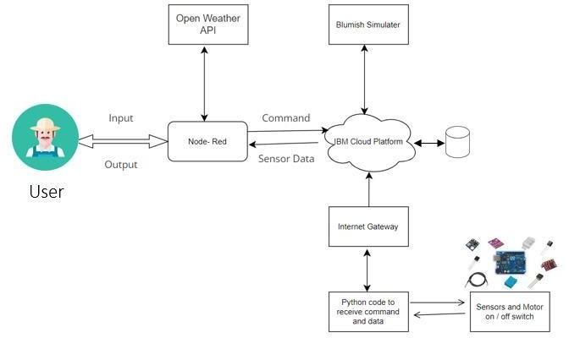

1. The different soil parameters like temperature, soil moisture and humidity are sensed using different sensors and obtained values are stored in the IBM cloud.
2. Arduino UNO is used as a processing Unit that process the data obtained from the sensors and data from the weather API.
3. NODE-RED is used as a programming tool to write the hardware, software and APIs.
4. The MQTT protocol is followed for communication process. Communicating between cloud and the user (Farmer).
5. All the collected data are provided to the user through a mobile application that was developed using the MIT app inventor.
6. The user could make a decision through an app, whether to water the field or not, depending upon the sensor values. By using the app, they can remotely operate the motor switch.

**Table 1: Components & Technologies:**

|  |  |  |  |
| --- | --- | --- | --- |
| **S. No** | **Component** | **Description** | **Technology** |
| 1. | User Interface | The communication protocol being used might act as an interface | MIT App Inventor |
| 2. | Arduino UNO | It is used as a processing Unit | Python |
| 3. | MQTT protocol | The data to be collected and sent to the farmer  via MQTT protocol providing the data to easily monitor the crops | IBM Watson IOT service, IBM Watson Assistant |
| 4. | Database | Data Type, Configurations | MySQL |
| 5. | Cloud Database | Database Service on Cloud | IBM Cloud |
| 6. | File Storage | Different soil parameters obtained values | IBM Block Storage |
| 7. | External API | To monitor the weather | Open Weather API |
| 8. | Infrastructure (Server / Cloud) | Application Deployment on  Cloud Local Server Configuration: Cloud Server Configuration: | Kubernetes |

**Table 2: Application Characteristics:**

|  |  |  |  |
| --- | --- | --- | --- |
| **S. No** | **Characteristics** | **Description** | **Technology** |
| 1. | Open-Source Frameworks | MQTT protocol | python |
| 2. | Security Implementations | Sensitive and private data must be protected from their production until the decision-making and storage stages. | Node-Red, Open weather App API, MIT App Inventor |
| 3. | Scalable Architecture | Scalability is a major concern for IoT platforms. It has been shown that different architectural choices of IoT platforms affect system scalability and that automatic real time decision-making is feasible in an environment composed of dozens of thousand. | Node-Red service |
| 4. | Availability | Available feasible | Open weather App |
| 5. | Performance | Design consideration for the performance of the application (number of requests per  sec, use of Cache, use of CDN’s) etc. | MIT app inventor |